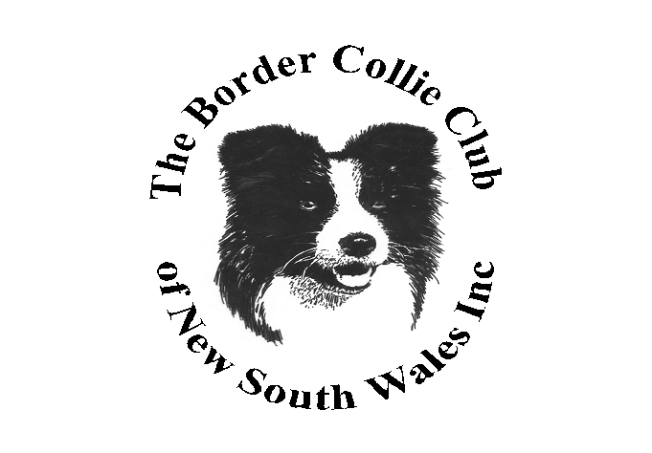

The Border Collie Club of NSW Inc
88th Championship Show and
Obedience, Rally and Agility/Jumping Trials
The Bill Spilsted Complex for Canine Affairs
44 Luddenham Rd, Orchard Hills NSW – GSD Grounds

Saturday 28 March 2026
(Entries close on Wednesday 25 March 2026 at 5pm)


Entries – Show, Obedience and Rally Trials: Online with Show Manager
Entries – Agility and Jumping Trial: Online with K9 Entries
Ph & Extreme Weather: 0416 382 138
Payments via Direct Debit only BSB: 112 879 Account Number: 464605286
Email Show /Trial Secretary: lcook52@hotmail.com for all enquiries and regarding how to enter
Phone Enquires: Up to 8.30pm only please 0416 382 138

Judging commences: 9am with Property Classes, Agility and Obedience
9.30am Rally
Conformation to follow Property (Not before 10am)
Judges:
Ms Lisa Waldo (USA) All Breed Classes and General Specials
Classes: 1,2,3,4,5,10,11 & 18 (Dogs and Bitches)
Property Judge Ms Tanya Scales (NSW):Property & Special Classes:
Sire and Offspring, Dam and Progeny, Gaited, Coated, Headed (Dogs & Bitches), Best Footed
Ms Jill Kaldor (NSW): Obedience – UDX, UD, CDX, CD and CCD
Mr Ron Probert (NSW): Rally – RM, RE, RA and RN
Mr Jason McFarlane(NSW): Agility and Jumping – ADO, ADM, ADX, AD, JDO, JDM,
Entry Fees: All Classes in Show and Trials: Members $14 Non - Members $16
Breed Baby puppies: $5
Breed Property Classes: $5

Catalogue On-line after 6pm evening prior to Show. Agility Catalogue can be downloaded 3 days prior to the trial.

Dogs NSW Representative: Mr Stephen Oliver (Breed)
Mrs Lynda Brandt (Obedience, Rally and Agility)

Camping: Please contact Dogs NSW
Refreshments: Limited - Available on main grounds

Prizes: Property: Prize and Sash for 1st, 2nd and 3rd in each Class
Breed: Prize and Rosette for BISS and RUBISS. Other Classes – Prize and Sash
Obedience: Prize and Sash for 1st, 2nd and 3rd (Qualifiers only)
Rally: Prize and Sash for 1st, 2nd and 3rd (Qualifiers only)
Agility and Jumping: Prize and Sash for 1st, 2nd and 3rd (Qualifiers only)

